**VRSP Associates Website Edit/Update Instructions**

***Please note that, we have structured few sections as per the design and flow needs. We will instruct you accordingly in this doc as well as via screenshots.

***Please take a backup of your website files (i.e. theme file, plugins, uploads and database) before updating anything in your site. You can also contact us for more details.

***Please click on “Save Changes”, “Save”, “Update” & “Publish” buttons to save or publish the page(s).

Follow below points (section) with screenshots provided for your better understanding:

1. **Header Section Instructions:**



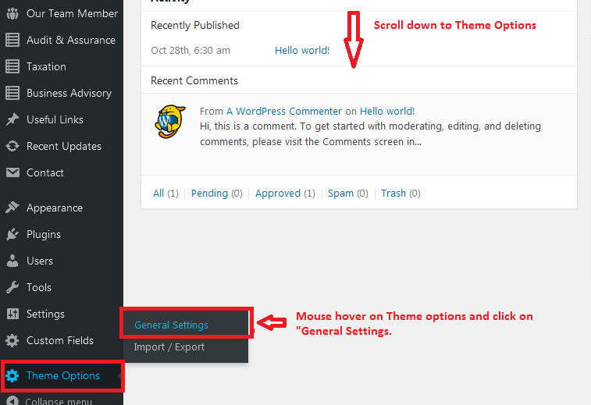

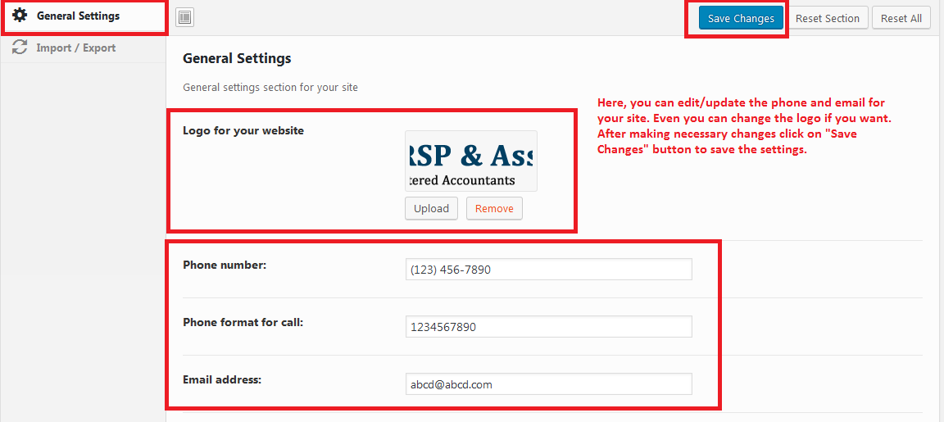

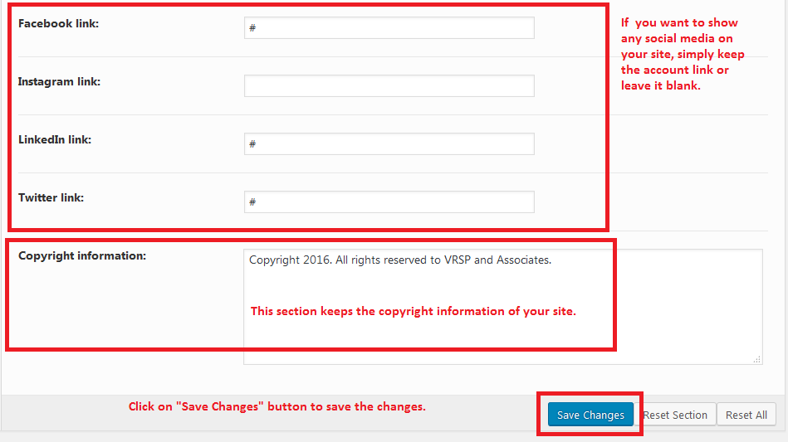

1. **Banner section instructions:**

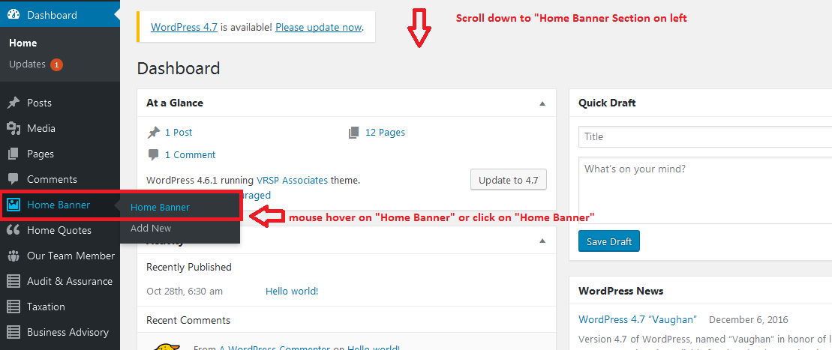

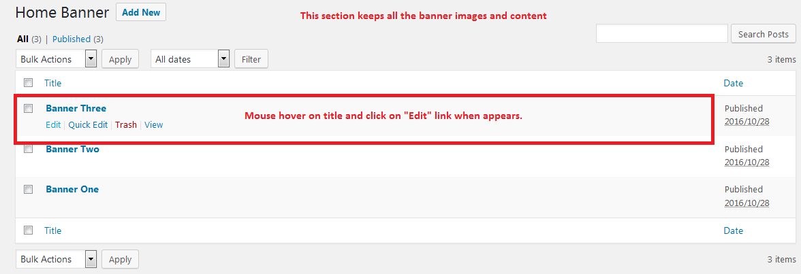

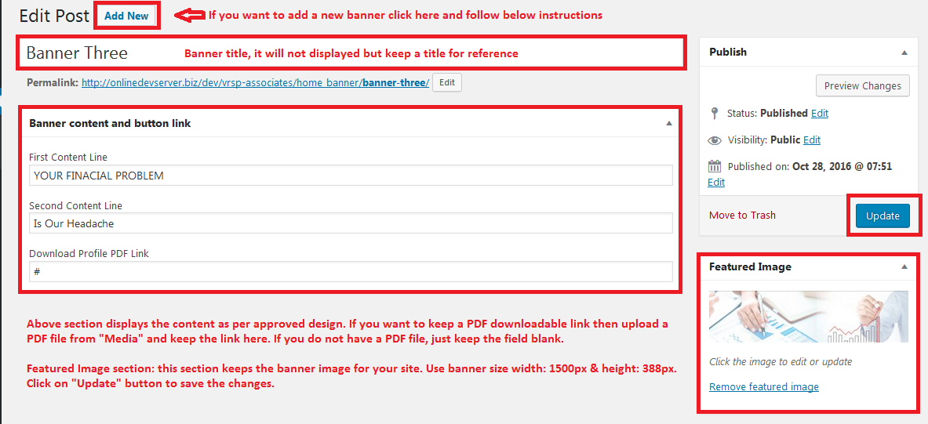

1. **Welcome section instructions:**



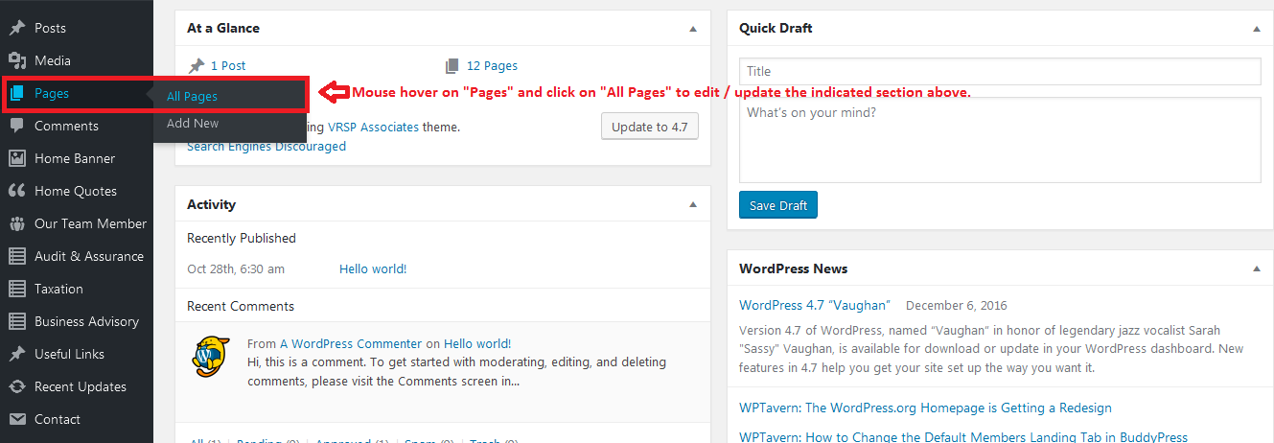

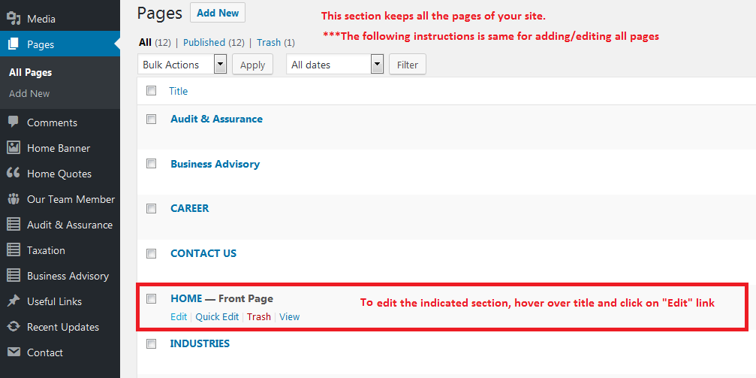

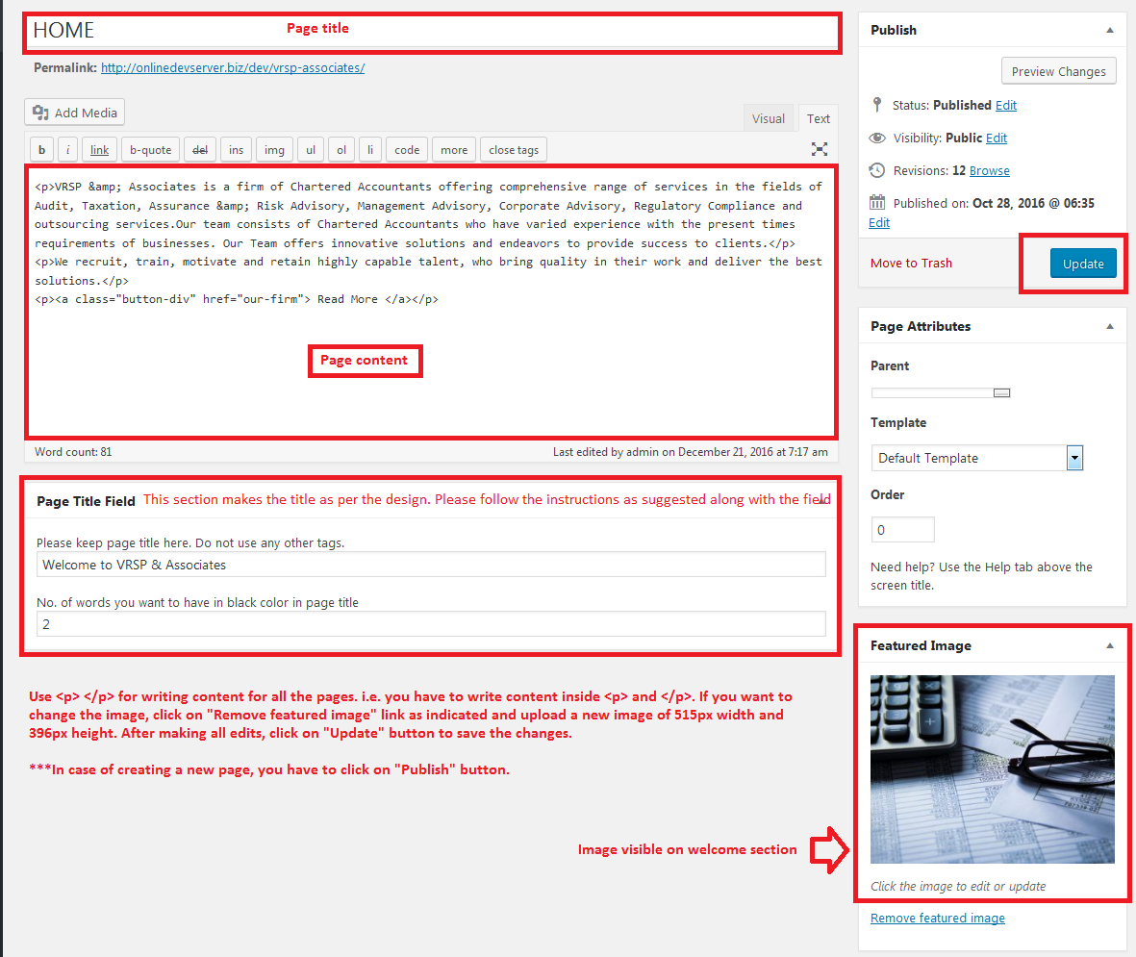

1. **Services We Do section:**



1. **Quote section instructions:**



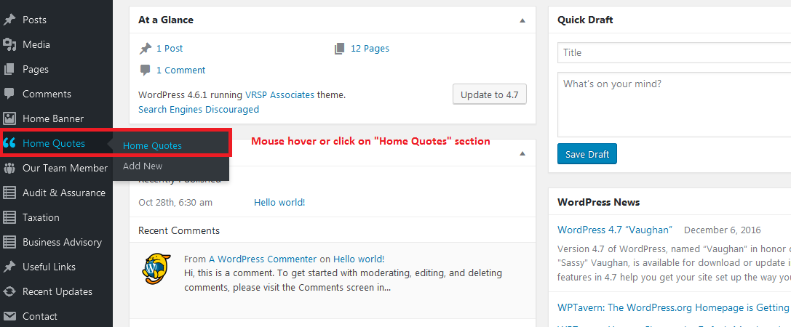

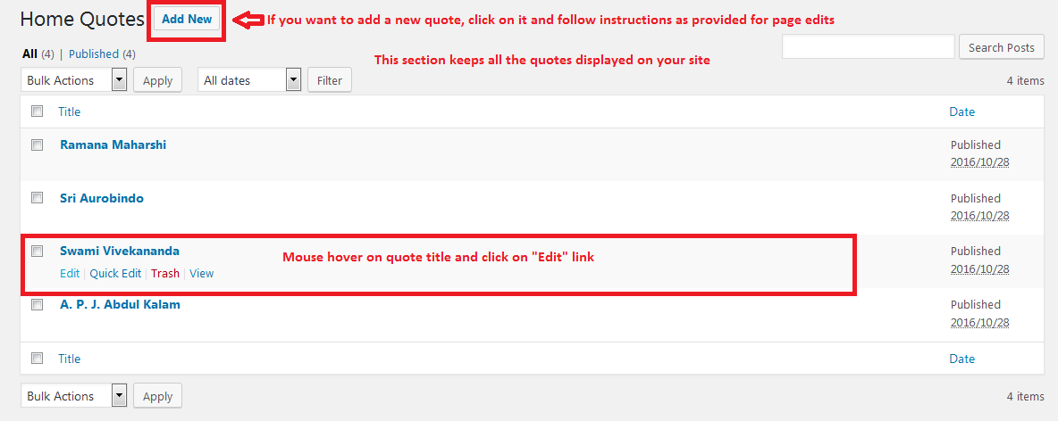

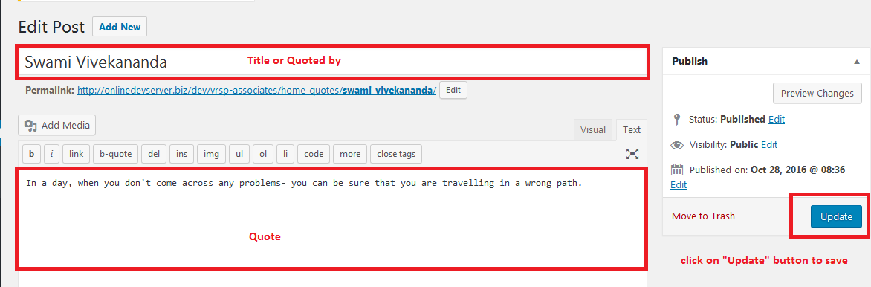

1. **Recent Updates & Our Team section instructions:**

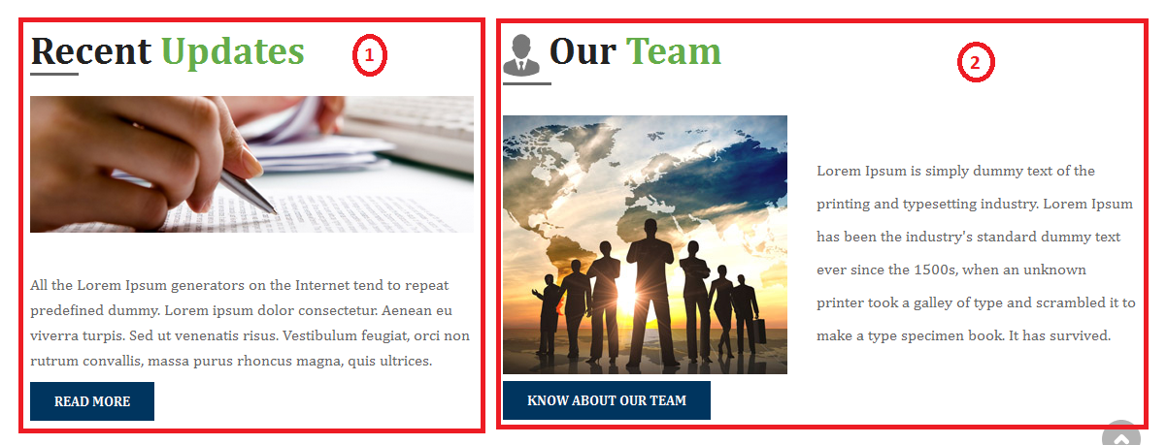

1. **Recent Updates:**

**\*\*\*Please note that, “Recent Updates” section is a special section so, we have structured it as per the design. The content in the screenshot comes from a single page but when you click on “Read More” it will direct you to a sections, whose contents are coming from a specially developed section.**

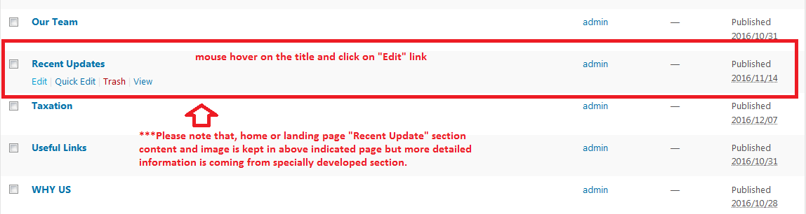

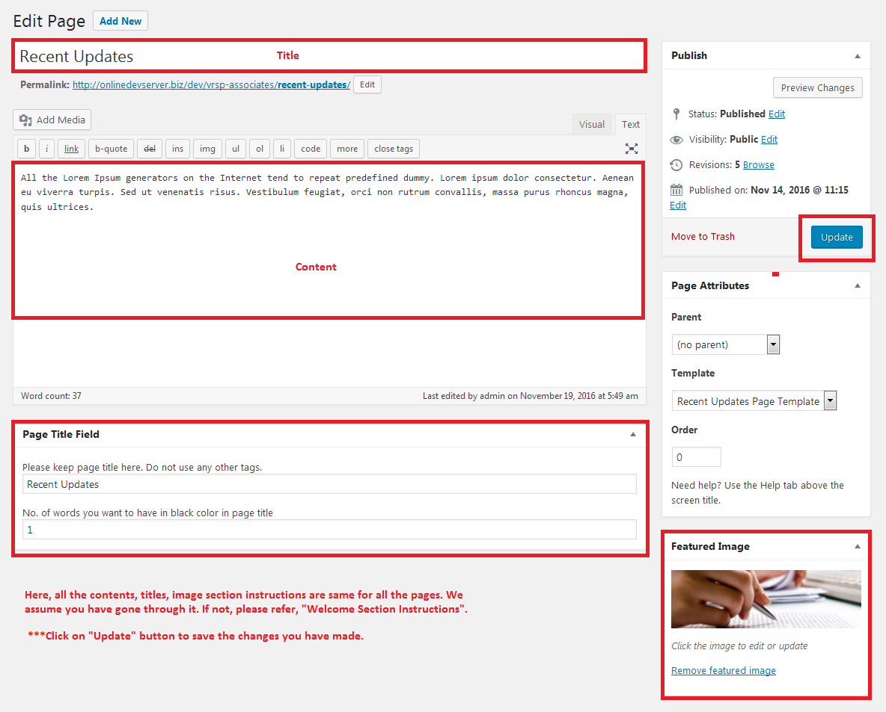

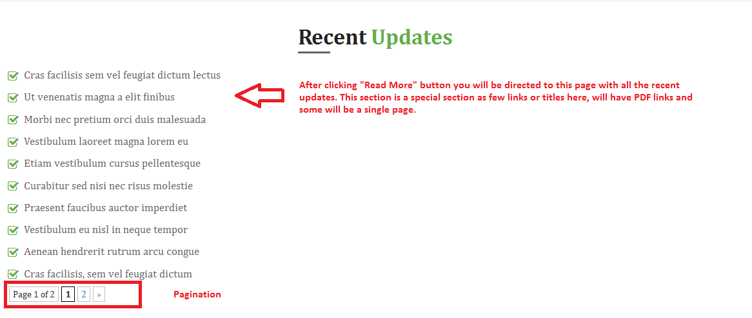

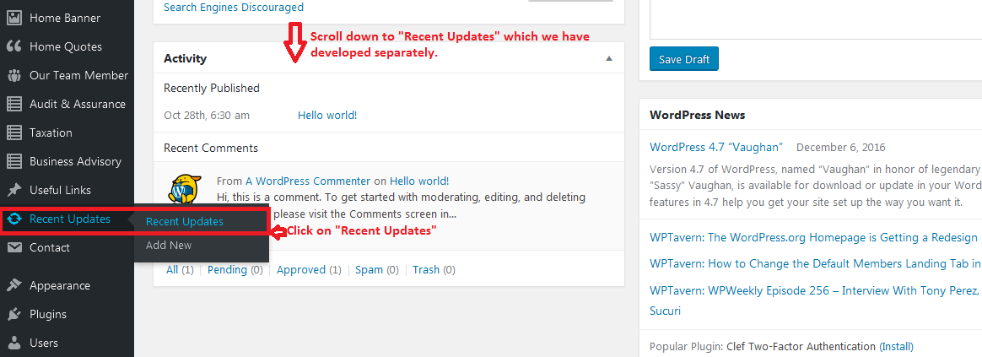

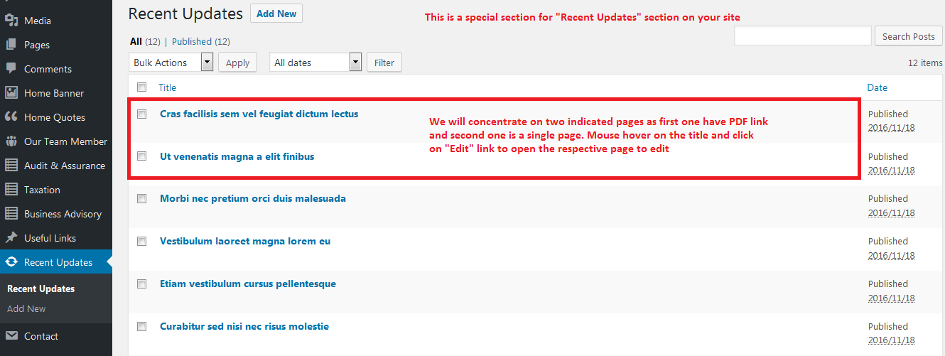

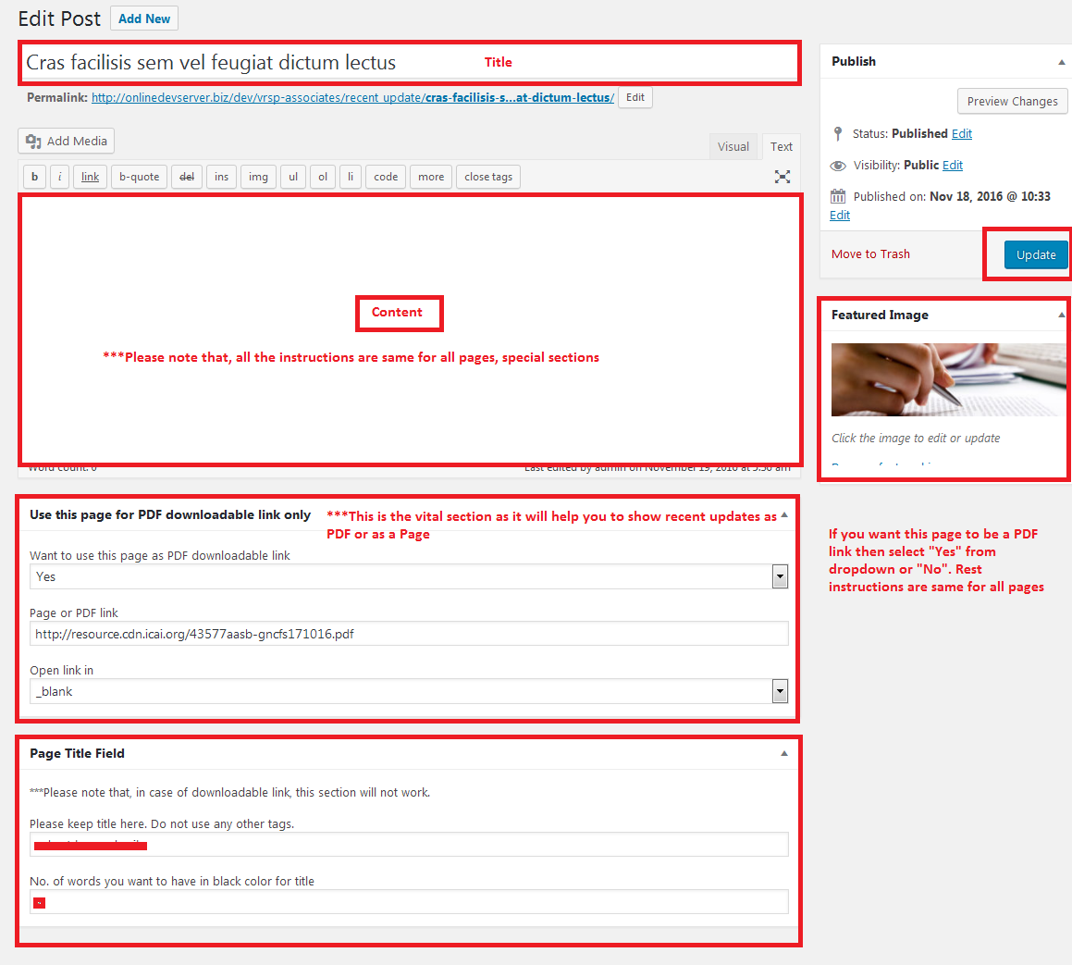

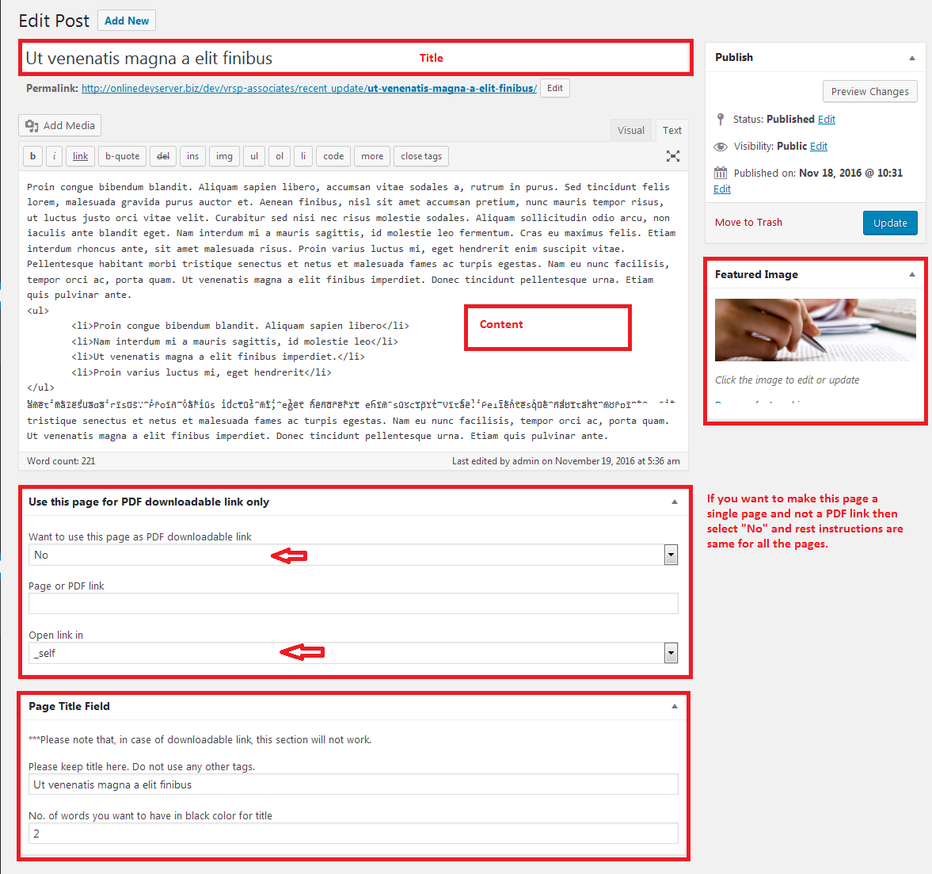

1. **Our Team:**

**\*\*\*This is again a special section where we have fetched the indicated or number section from a single page but when you click on “Know About Our Team” button you will be directed to a page with different layout. Please follow below instructions for your better understanding.**

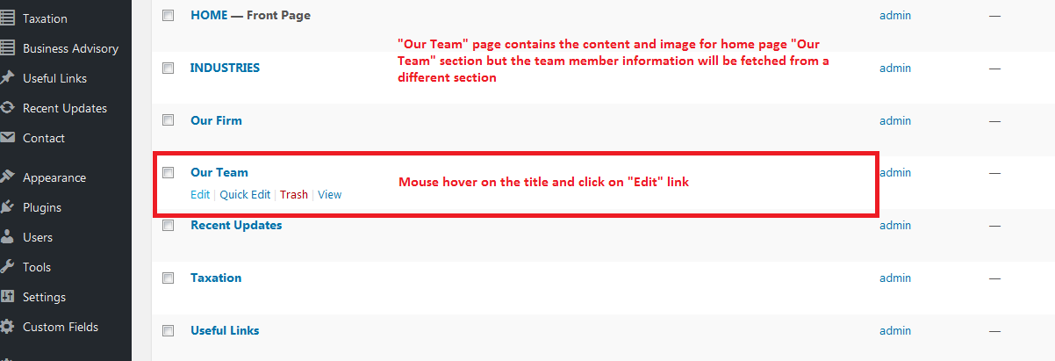

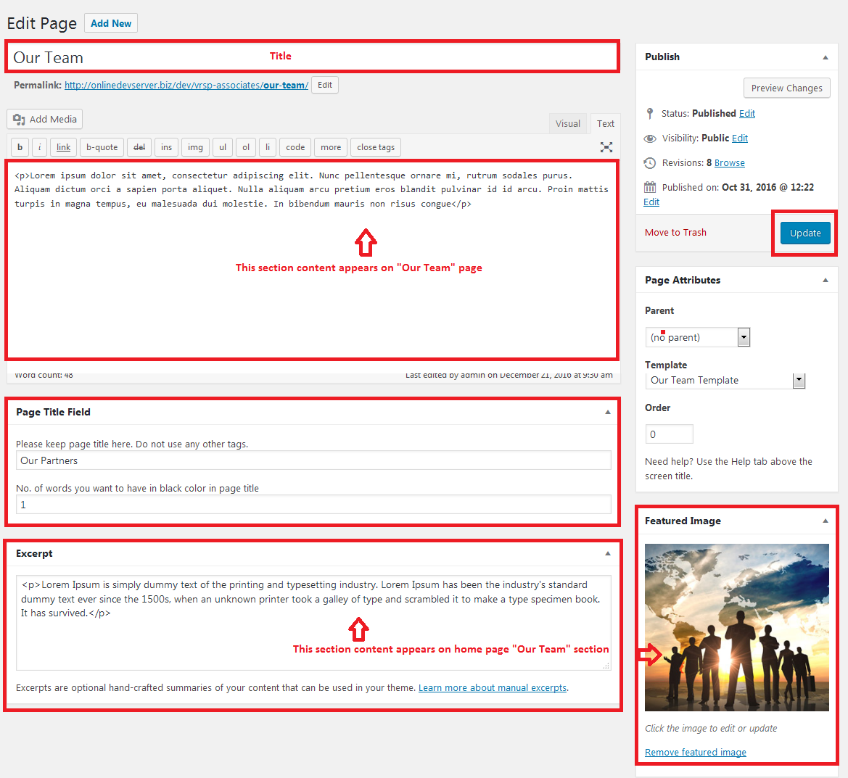

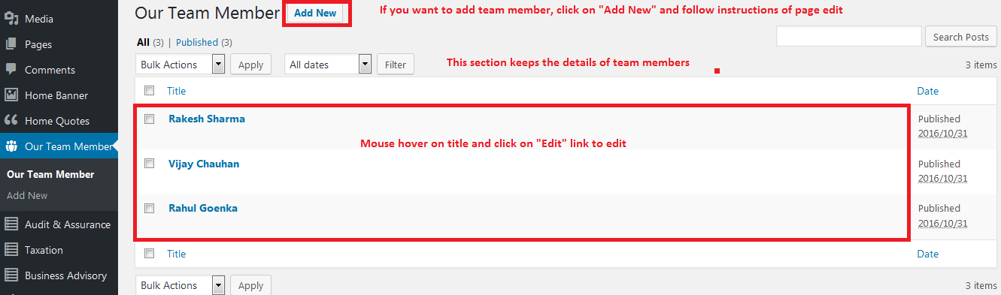

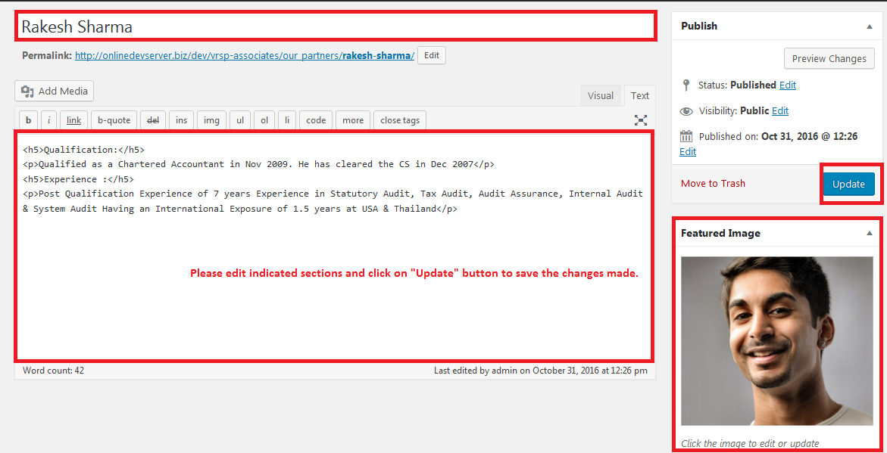

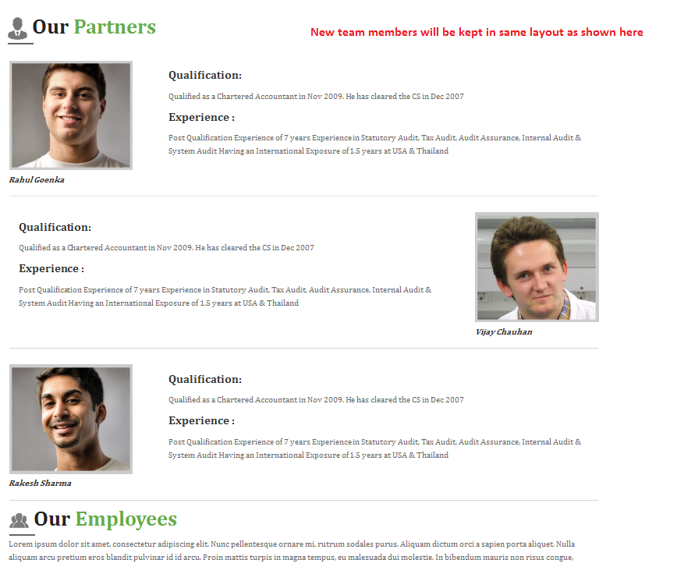

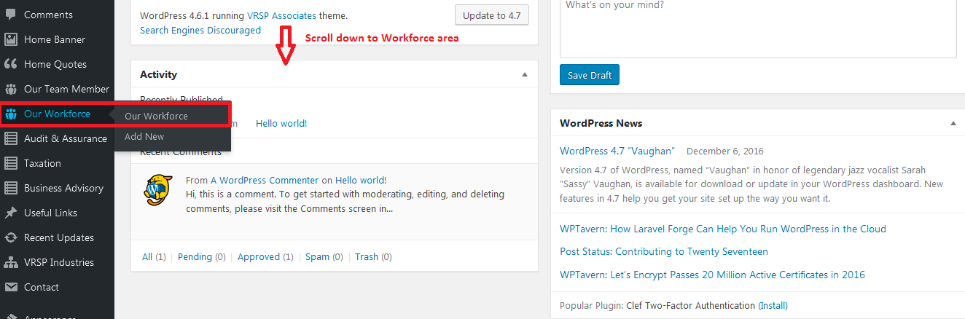

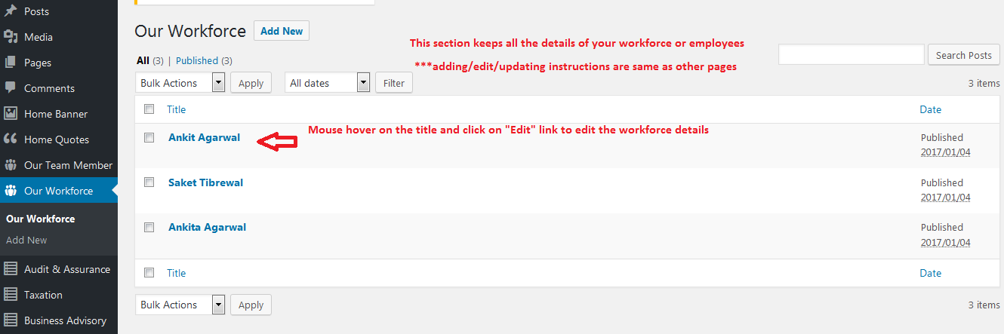

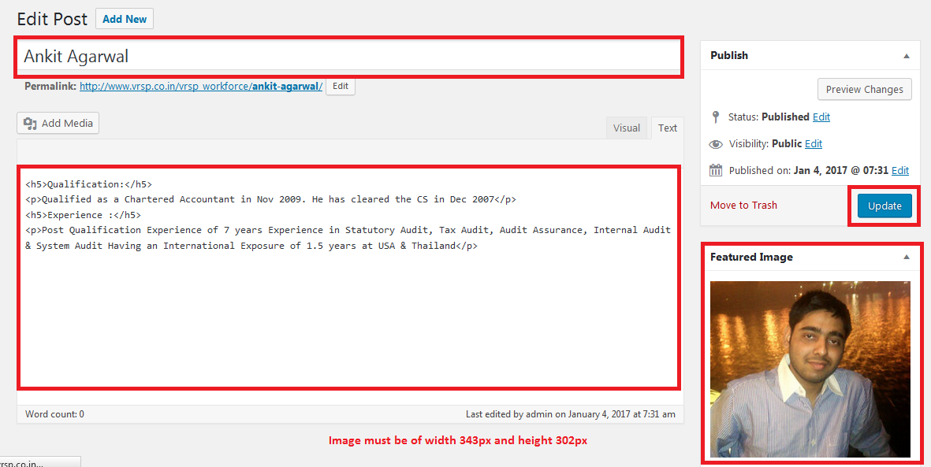

1. **Tax calendar section instructions:**

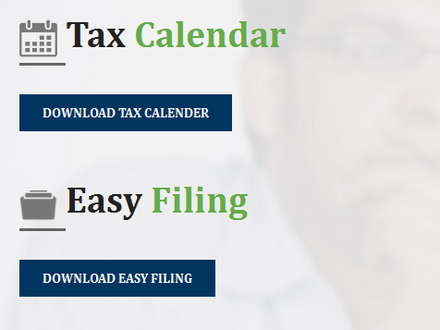

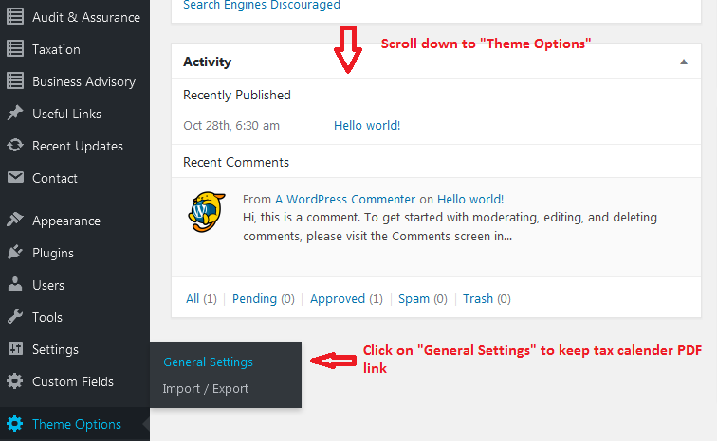

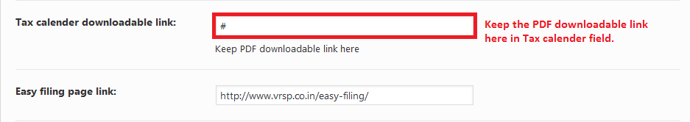

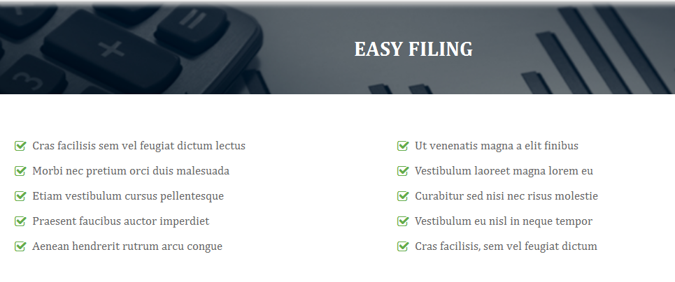

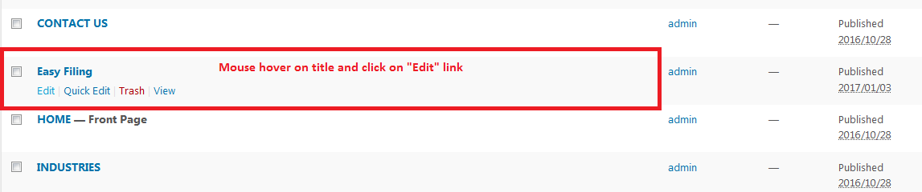

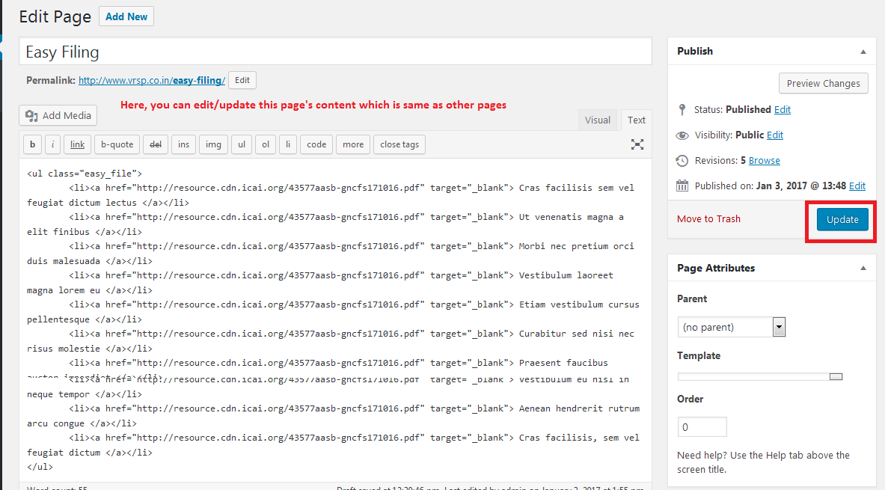

1. **Useful links sections instructions:**

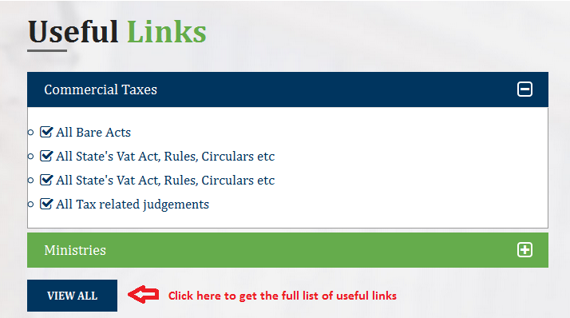

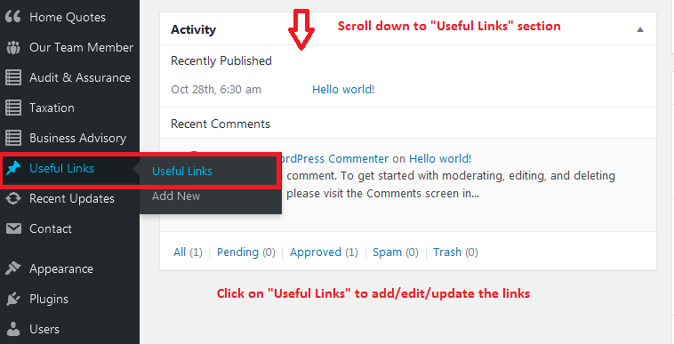

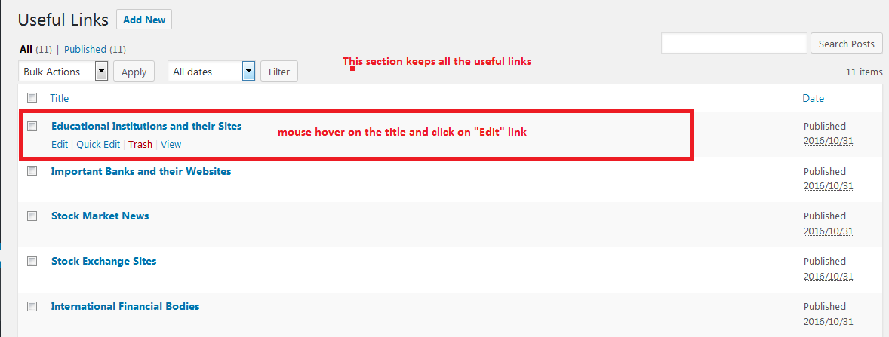

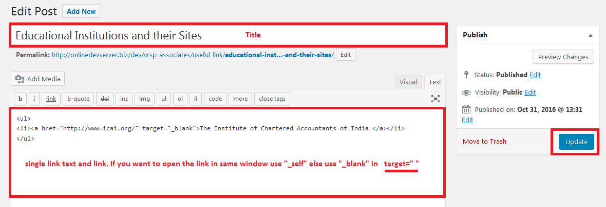

1. **Footer section instructions:**

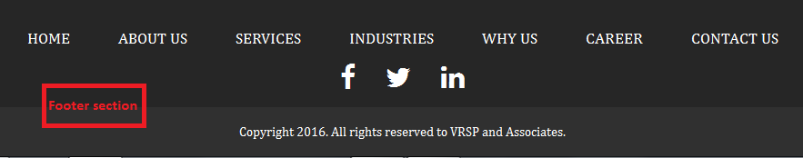

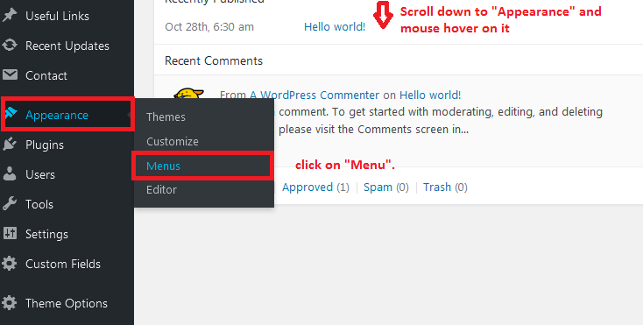

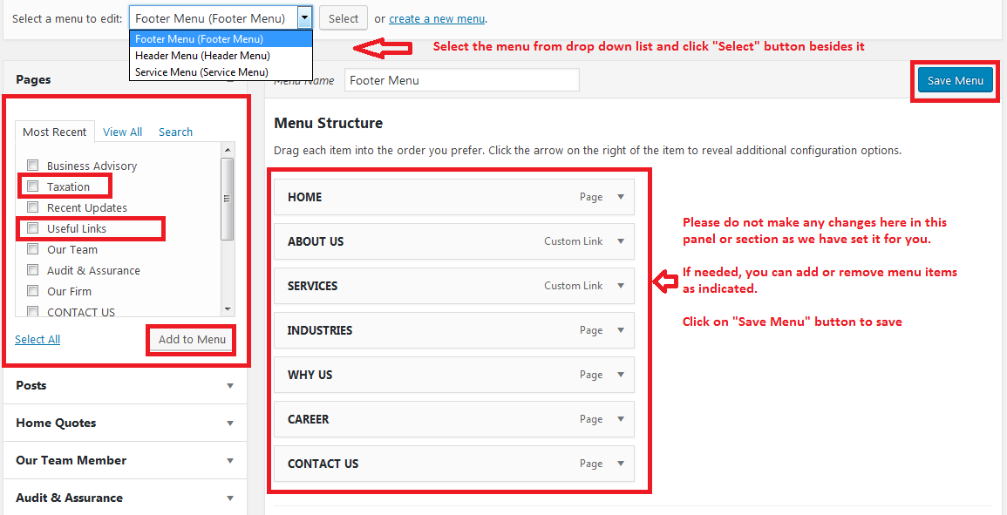

**\*\*\*We will provide you instructions for some more special pages with different layout.**

1. **Contact Page instructions:**

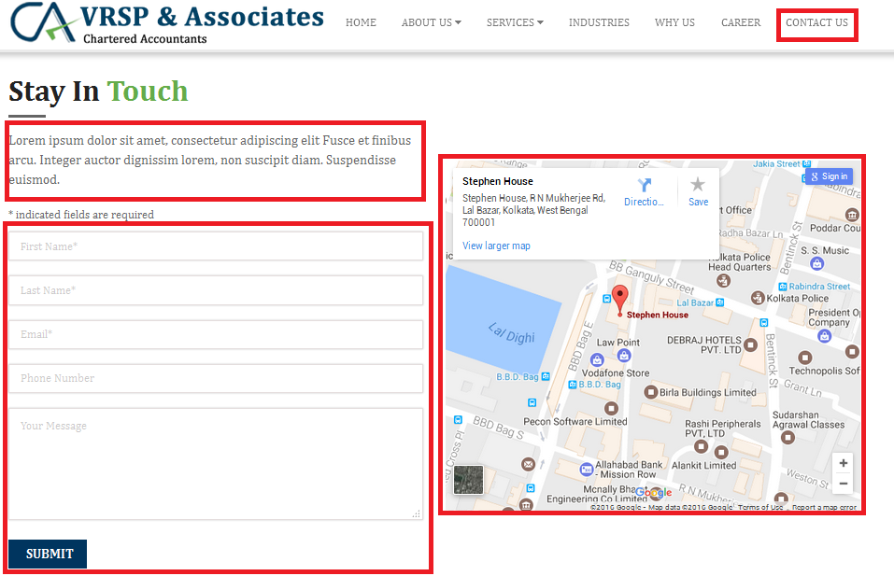

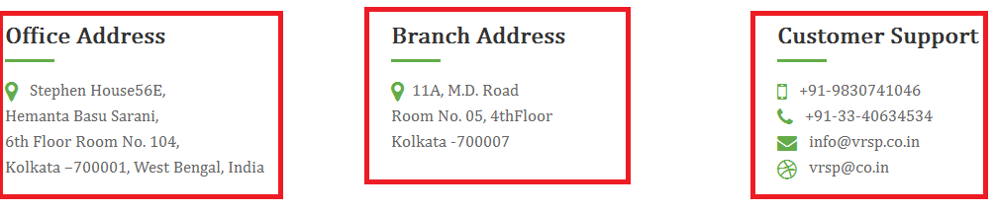



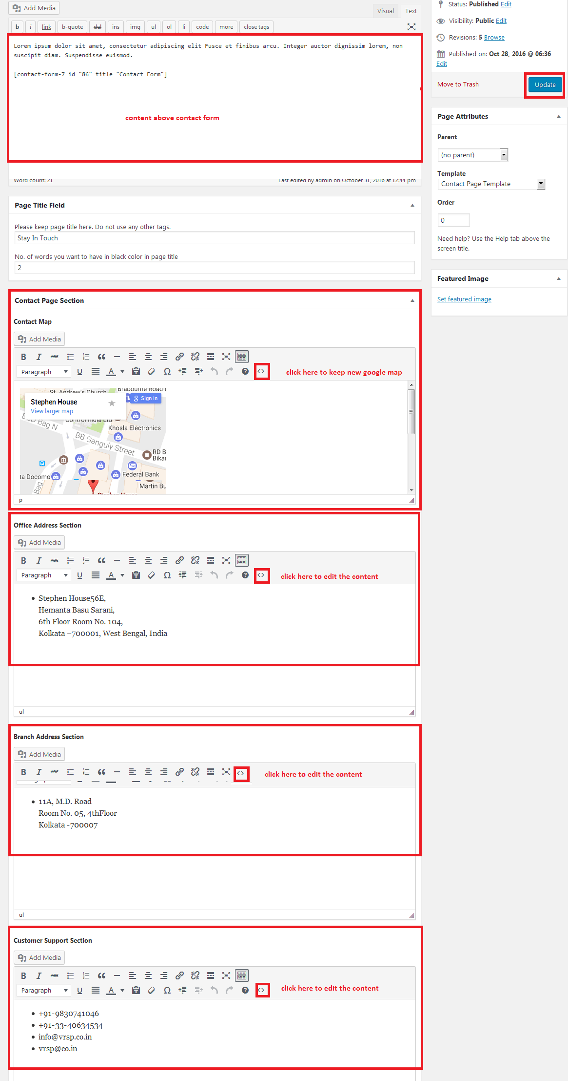

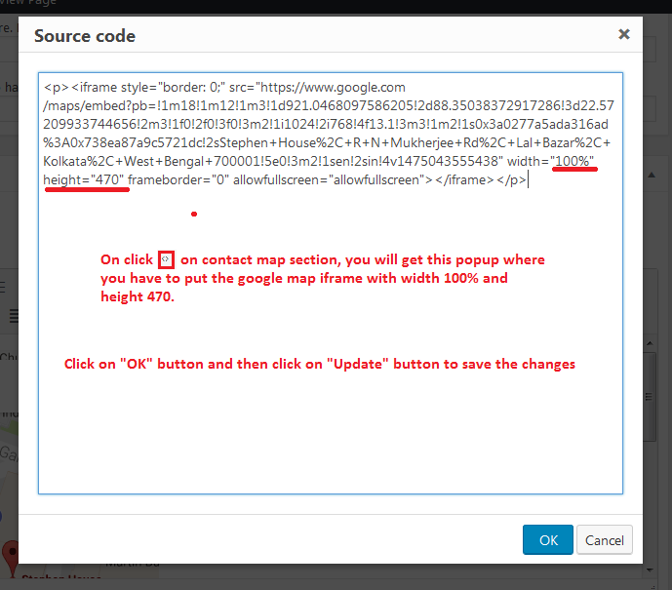

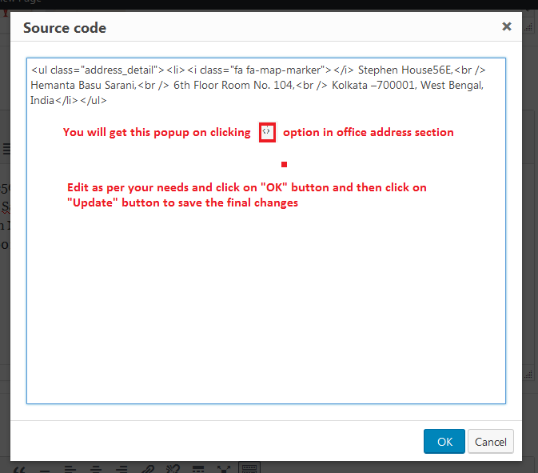

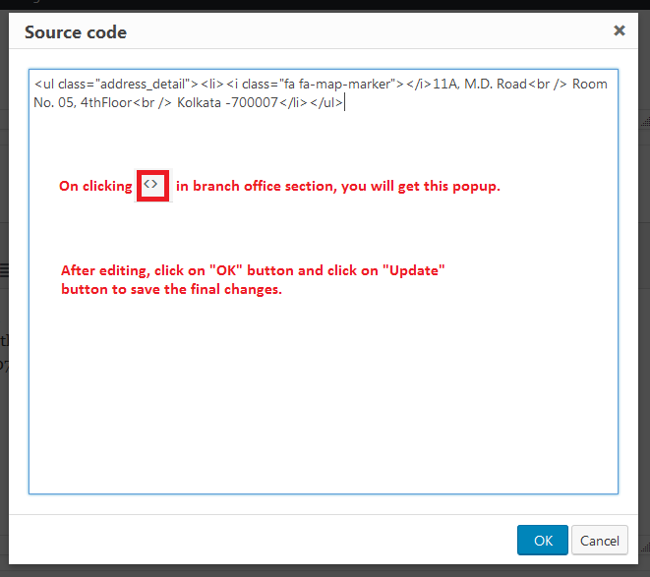

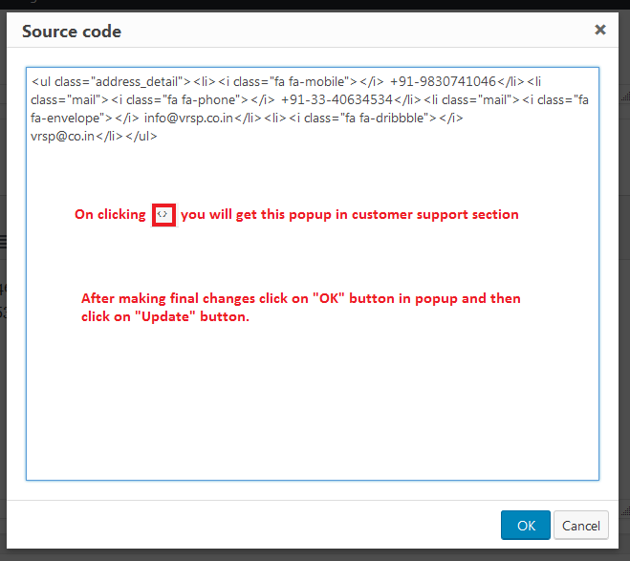

1. **Career Page Instructions:**

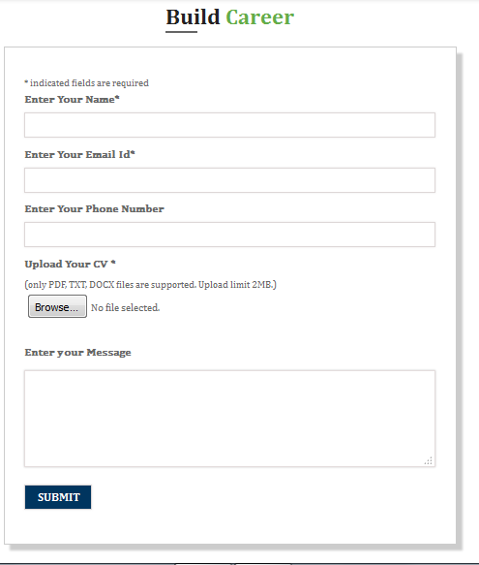

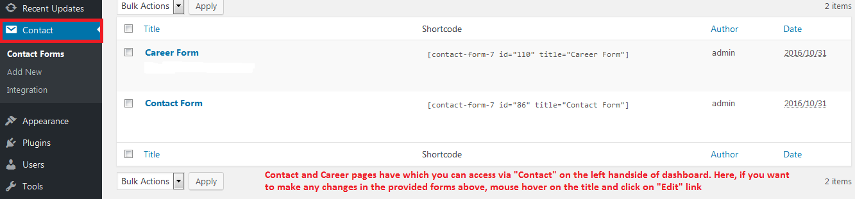

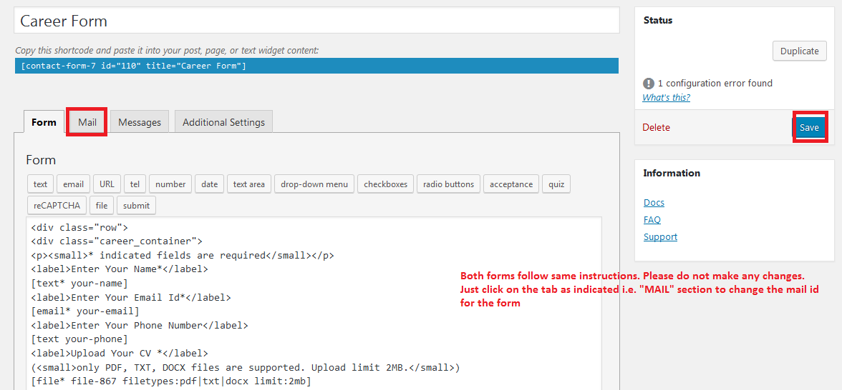

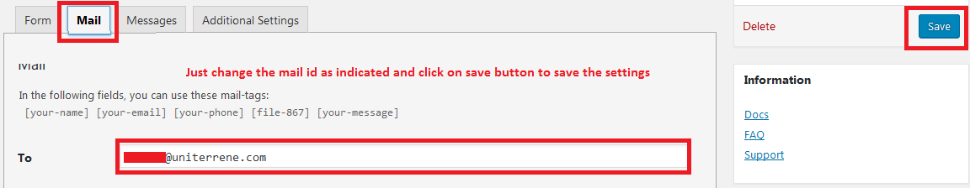

1. **Industries page instructions:**

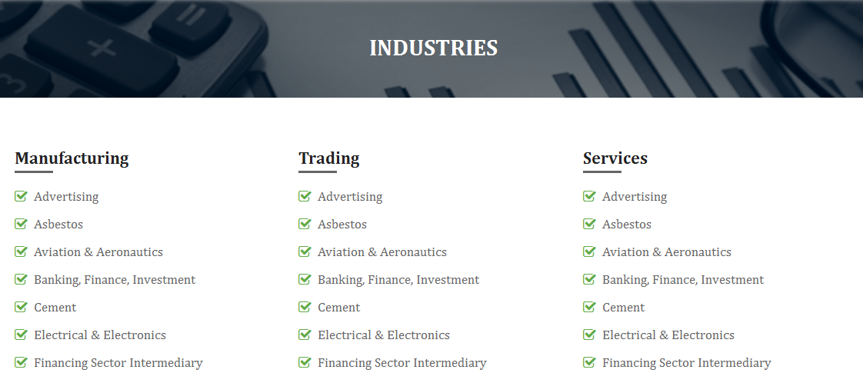

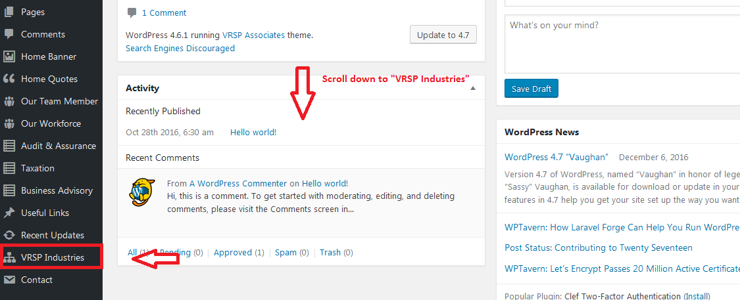

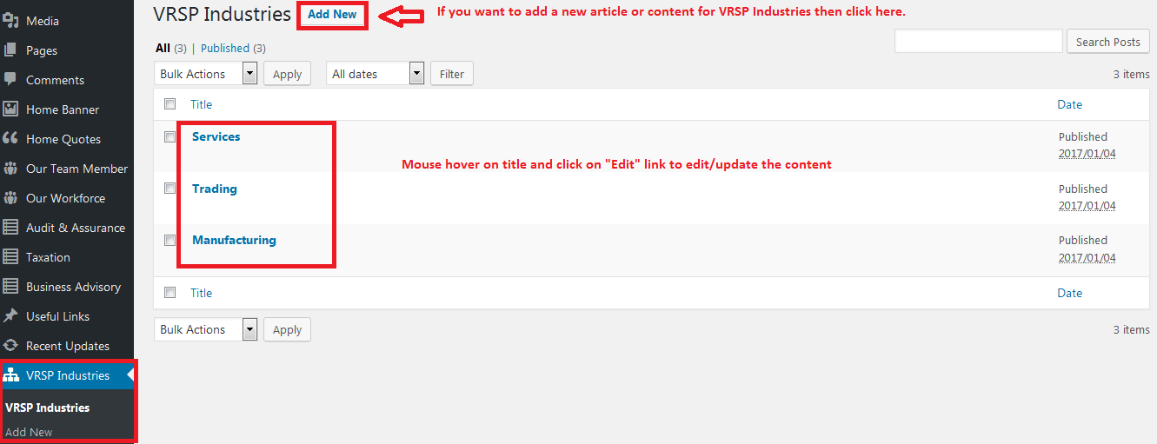

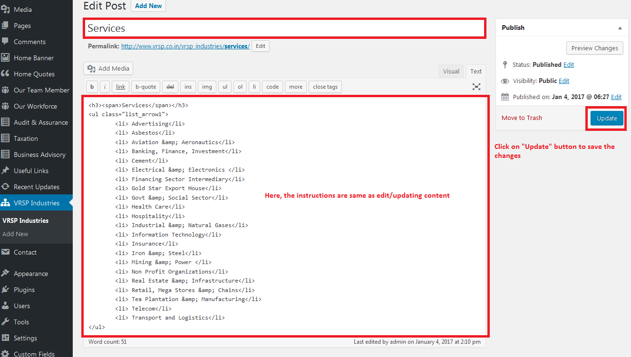

**\*\*\*If you need any other instructions anywhere in the site or find it difficult to understand the instructions, then kindly let us know about this. We will try to make the instructions as simple as possible.**